**Super Keyword in Java**

The **super** keyword in Java is a reference variable which is used to refer immediate parent class object.

Whenever you create the instance of subclass, an instance of parent class is created implicitly which is referred by super reference variable.

**Usage of Java super Keyword**

1. super can be used to refer immediate parent class instance variable.
2. super can be used to invoke immediate parent class method.
3. super() can be used to invoke immediate parent class constructor.

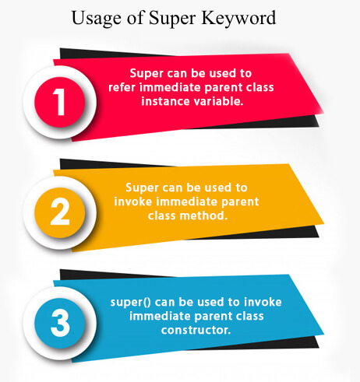

**1) super is used to refer immediate parent class instance variable.**

We can use super keyword to access the data member or field of parent class. It is used if parent class and child class have same fields.

1. class Animal{
2. String color="white";
3. }
4. class Dog extends Animal{
5. String color="black";
6. void printColor(){
7. System.out.println(color);//prints color of Dog class
8. System.out.println(super.color);//prints color of Animal class
9. }
10. }
11. class TestSuper1{
12. public static void main(String args[]){
13. Dog d=new Dog();
14. d.printColor();
15. }}

[Test it Now](https://www.javatpoint.com/opr/test.jsp?filename=TestSuper1)

Output:

Competitive questions on Structures in HindiKeep Watching

black

white

In the above example, Animal and Dog both classes have a common property color. If we print color property, it will print the color of current class by default. To access the parent property, we need to use super keyword.

**2) super can be used to invoke parent class method**

The super keyword can also be used to invoke parent class method. It should be used if subclass contains the same method as parent class. In other words, it is used if method is overridden.

1. class Animal{
2. void eat(){System.out.println("eating...");}
3. }
4. class Dog extends Animal{
5. void eat(){System.out.println("eating bread...");}
6. void bark(){System.out.println("barking...");}
7. void work(){
8. super.eat();
9. bark();
10. }
11. }
12. class TestSuper2{
13. public static void main(String args[]){
14. Dog d=new Dog();
15. d.work();
16. }}

[Test it Now](https://www.javatpoint.com/opr/test.jsp?filename=TestSuper2)

Output:

eating...

barking...

In the above example Animal and Dog both classes have eat() method if we call eat() method from Dog class, it will call the eat() method of Dog class by default because priority is given to local.

To call the parent class method, we need to use super keyword.

**3) super is used to invoke parent class constructor.**

The super keyword can also be used to invoke the parent class constructor. Let's see a simple example:

1. class Animal{
2. Animal(){System.out.println("animal is created");}
3. }
4. class Dog extends Animal{
5. Dog(){
6. super();
7. System.out.println("dog is created");
8. }
9. }
10. class TestSuper3{
11. public static void main(String args[]){
12. Dog d=new Dog();
13. }}

[Test it Now](https://www.javatpoint.com/opr/test.jsp?filename=TestSuper3)

Output:

animal is created

dog is created

**Note: super() is added in each class constructor automatically by compiler if there is no super() or this().**

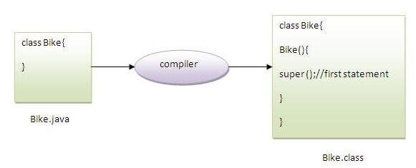

As we know well that default constructor is provided by compiler automatically if there is no constructor. But, it also adds super() as the first statement.

**Another example of super keyword where super() is provided by the compiler implicitly.**

1. class Animal{
2. Animal(){System.out.println("animal is created");}
3. }
4. class Dog extends Animal{
5. Dog(){
6. System.out.println("dog is created");
7. }
8. }
9. class TestSuper4{
10. public static void main(String args[]){
11. Dog d=new Dog();
12. }}

[Test it Now](https://www.javatpoint.com/opr/test.jsp?filename=TestSuper4)

Output:

animal is created

dog is created

**super example: real use**

Let's see the real use of super keyword. Here, Emp class inherits Person class so all the properties of Person will be inherited to Emp by default. To initialize all the property, we are using parent class constructor from child class. In such way, we are reusing the parent class constructor.

1. class Person{
2. int id;
3. String name;
4. Person(int id,String name){
5. this.id=id;
6. this.name=name;
7. }
8. }
9. class Emp extends Person{
10. float salary;
11. Emp(int id,String name,float salary){
12. super(id,name);//reusing parent constructor
13. this.salary=salary;
14. }
15. void display(){System.out.println(id+" "+name+" "+salary);}
16. }
17. class TestSuper5{
18. public static void main(String[] args){
19. Emp e1=new Emp(1,"ankit",45000f);
20. e1.display();
21. }}

[Test it Now](https://www.javatpoint.com/opr/test.jsp?filename=TestSuper5)

Output:

1 ankit 45000

# Instance initializer block

|  |
| --- |
| **Instance Initializer block** is used to initialize the instance data member. It run each time when object of the class is created. |
| The initialization of the instance variable can be done directly but there can be performed extra operations while initializing the instance variable in the instance initializer block. |

#### Que) What is the use of instance initializer block while we can directly assign a value in instance data member? For example:

1. class Bike{
2. int speed=100;
3. }

## Why use instance initializer block?

|  |
| --- |
| Suppose I have to perform some operations while assigning value to instance data member e.g. a for loop to fill a complex array or error handling etc. |

### Example of instance initializer block

|  |
| --- |
| Let's see the simple example of instance initializer block that performs initialization. |

1. class Bike7{
2. int speed;
4. Bike7(){System.out.println("speed is "+speed);}
6. {speed=100;}
8. public static void main(String args[]){
9. Bike7 b1=new Bike7();
10. Bike7 b2=new Bike7();
11. }
12. }

[Test it Now](https://www.javatpoint.com/opr/test.jsp?filename=Bike7)

Output:speed is 100

speed is 100

|  |
| --- |
| There are three places in java where you can perform operations:   1. method 2. constructor 3. block |

## What is invoked first, instance initializer block or constructor?

1. class Bike8{
2. int speed;
4. Bike8(){System.out.println("constructor is invoked");}
6. {System.out.println("instance initializer block invoked");}
8. public static void main(String args[]){
9. Bike8 b1=new Bike8();
10. Bike8 b2=new Bike8();
11. }
12. }

[Test it Now](https://www.javatpoint.com/opr/test.jsp?filename=Bike8)

Output:instance initializer block invoked

constructor is invoked

instance initializer block invoked

constructor is invoked

|  |
| --- |
| In the above example, it seems that instance initializer block is firstly invoked but NO. Instance intializer block is invoked at the time of object creation. The java compiler copies the instance initializer block in the constructor after the first statement super(). So firstly, constructor is invoked. Let's understand it by the figure given below: |

#### Note: The java compiler copies the code of instance initializer block in every constructor.

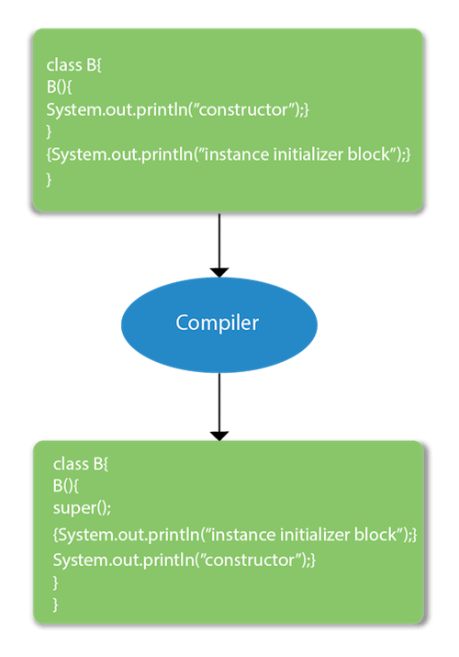

## Rules for instance initializer block :

|  |
| --- |
| There are mainly three rules for the instance initializer block. They are as follows: |

1. The instance initializer block is created when instance of the class is created.
2. The instance initializer block is invoked after the parent class constructor is invoked (i.e. after super() constructor call).
3. The instance initializer block comes in the order in which they appear.

## Program of instance initializer block that is invoked after super()

1. class A{
2. A(){
3. System.out.println("parent class constructor invoked");
4. }
5. }
6. class B2 extends A{
7. B2(){
8. super();
9. System.out.println("child class constructor invoked");
10. }
12. {System.out.println("instance initializer block is invoked");}
14. public static void main(String args[]){
15. B2 b=new B2();
16. }
17. }

[Test it Now](https://www.javatpoint.com/opr/test.jsp?filename=B2)

Output:parent class constructor invoked

instance initializer block is invoked

child class constructor invoked

## Another example of instance block

1. class A{
2. A(){
3. System.out.println("parent class constructor invoked");
4. }
5. }
7. class B3 extends A{
8. B3(){
9. super();
10. System.out.println("child class constructor invoked");
11. }
13. B3(int a){
14. super();
15. System.out.println("child class constructor invoked "+a);
16. }
18. {System.out.println("instance initializer block is invoked");}
20. public static void main(String args[]){
21. B3 b1=new B3();
22. B3 b2=new B3(10);
23. }
24. }

[Test it Now](https://www.javatpoint.com/opr/test.jsp?filename=B3)

parent class constructor invoked

instance initializer block is invoked

child class constructor invoked

parent class constructor invoked

instance initializer block is invoked

child class constructor invoked 10

# Final Keyword In Java

The **final keyword** in java is used to restrict the user. The java final keyword can be used in many context. Final can be:

1. variable
2. method
3. class

The final keyword can be applied with the variables, a final variable that have no value it is called blank final variable or uninitialized final variable. It can be initialized in the constructor only. The blank final variable can be static also which will be initialized in the static block only. We will have detailed learning of these. Let's first learn the basics of final keyword.

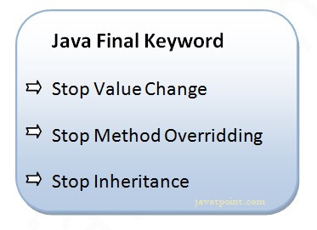

## 1) Java final variable

If you make any variable as final, you cannot change the value of final variable(It will be constant).

### Example of final variable

There is a final variable speedlimit, we are going to change the value of this variable, but It can't be changed because final variable once assigned a value can never be changed.

1. class Bike9{
2. final int speedlimit=90;//final variable
3. void run(){
4. speedlimit=400;
5. }
6. public static void main(String args[]){
7. Bike9 obj=new  Bike9();
8. obj.run();
9. }
10. }//end of class

[Test it Now](https://www.javatpoint.com/opr/test.jsp?filename=Bike9)

Output:Compile Time Error

## 2) Java final method

If you make any method as final, you cannot override it.

### Example of final method

1. class Bike{
2. final void run(){System.out.println("running");}
3. }
5. class Honda extends Bike{
6. void run(){System.out.println("running safely with 100kmph");}
8. public static void main(String args[]){
9. Honda honda= new Honda();
10. honda.run();
11. }
12. }

[Test it Now](https://www.javatpoint.com/opr/test.jsp?filename=Honda)

Output:Compile Time Error

## 3) Java final class

If you make any class as final, you cannot extend it.

### Example of final class

1. final class Bike{}
3. class Honda1 extends Bike{
4. void run(){System.out.println("running safely with 100kmph");}
6. public static void main(String args[]){
7. Honda1 honda= new Honda1();
8. honda.run();
9. }
10. }

[Test it Now](https://www.javatpoint.com/opr/test.jsp?filename=Honda1)

Output:Compile Time Error

### Q) Is final method inherited?

Ans) Yes, final method is inherited but you cannot override it. For Example:

1. class Bike{
2. final void run(){System.out.println("running...");}
3. }
4. class Honda2 extends Bike{
5. public static void main(String args[]){
6. new Honda2().run();
7. }
8. }

[Test it Now](https://www.javatpoint.com/opr/test.jsp?filename=Honda2)

Output:running...

### Q) What is blank or uninitialized final variable?

A final variable that is not initialized at the time of declaration is known as blank final variable.

If you want to create a variable that is initialized at the time of creating object and once initialized may not be changed, it is useful. For example PAN CARD number of an employee.

It can be initialized only in constructor.

### Example of blank final variable

1. class Student{
2. int id;
3. String name;
4. final String PAN_CARD_NUMBER;
5. ...
6. }

### Que) Can we initialize blank final variable?

Yes, but only in constructor. For example:

1. class Bike10{
2. final int speedlimit;//blank final variable
4. Bike10(){
5. speedlimit=70;
6. System.out.println(speedlimit);
7. }
9. public static void main(String args[]){
10. new Bike10();
11. }
12. }

[Test it Now](https://www.javatpoint.com/opr/test.jsp?filename=Bike10)

Output: 70

### static blank final variable

A static final variable that is not initialized at the time of declaration is known as static blank final variable. It can be initialized only in static block.

### Example of static blank final variable

1. class A{
2. static final int data;//static blank final variable
3. static{ data=50;}
4. public static void main(String args[]){
5. System.out.println(A.data);
6. }
7. }

### Q) What is final parameter?

If you declare any parameter as final, you cannot change the value of it.

1. class Bike11{
2. int cube(final int n){
3. n=n+2;//can't be changed as n is final
4. n*n*n;
5. }
6. public static void main(String args[]){
7. Bike11 b=new Bike11();
8. b.cube(5);
9. }
10. }

[Test it Now](https://www.javatpoint.com/opr/test.jsp?filename=Bike11)

Output: Compile Time Error

### Q) Can we declare a constructor final?

No, because constructor is never inherited.

# Method Overloading in Java

If a [class](https://www.javatpoint.com/object-and-class-in-java) has multiple methods having same name but different in parameters, it is known as **Method Overloading**.

If we have to perform only one operation, having same name of the methods increases the readability of the [program](https://www.javatpoint.com/java-programs).

Suppose you have to perform addition of the given numbers but there can be any number of arguments, if you write the method such as a(int,int) for two parameters, and b(int,int,int) for three parameters then it may be difficult for you as well as other programmers to understand the behavior of the method because its name differs.

So, we perform method overloading to figure out the program quickly.



## Advantage of method overloading

Method overloading increases the readability of the program.

### Different ways to overload the method

There are two ways to overload the method in java

1. By changing number of arguments
2. By changing the data type

#### In Java, Method Overloading is not possible by changing the return type of the method only.

### 1) Method Overloading: changing no. of arguments

In this example, we have created two methods, first add() method performs addition of two numbers and second add method performs addition of three numbers.

In this example, we are creating [static methods](https://www.javatpoint.com/static-keyword-in-java) so that we don't need to create instance for calling methods.

1. class Adder{
2. static int add(int a,int b){return a+b;}
3. static int add(int a,int b,int c){return a+b+c;}
4. }
5. class TestOverloading1{
6. public static void main(String[] args){
7. System.out.println(Adder.add(11,11));
8. System.out.println(Adder.add(11,11,11));
9. }}

[Test it Now](https://www.javatpoint.com/opr/test.jsp?filename=TestOverloading1)

Output:

22

33

### 2) Method Overloading: changing data type of arguments

In this example, we have created two methods that differs in [data type](https://www.javatpoint.com/java-data-types). The first add method receives two integer arguments and second add method receives two double arguments.

1. class Adder{
2. static int add(int a, int b){return a+b;}
3. static double add(double a, double b){return a+b;}
4. }
5. class TestOverloading2{
6. public static void main(String[] args){
7. System.out.println(Adder.add(11,11));
8. System.out.println(Adder.add(12.3,12.6));
9. }}

[Test it Now](https://www.javatpoint.com/opr/test.jsp?filename=TestOverloading2)

Output:

22

24.9

### Q) Why Method Overloading is not possible by changing the return type of method only?

In java, method overloading is not possible by changing the return type of the method only because of ambiguity. Let's see how ambiguity may occur:

1. class Adder{
2. static int add(int a,int b){return a+b;}
3. static double add(int a,int b){return a+b;}
4. }
5. class TestOverloading3{
6. public static void main(String[] args){
7. System.out.println(Adder.add(11,11));//ambiguity
8. }}

[Test it Now](https://www.javatpoint.com/opr/test.jsp?filename=TestOverloading3)

Output:

Compile Time Error: method add(int,int) is already defined in class Adder

System.out.println(Adder.add(11,11)); //Here, how can java determine which sum() method should be called?

#### Note: Compile Time Error is better than Run Time Error. So, java compiler renders compiler time error if you declare the same method having same parameters.

### Can we overload java main() method?

Yes, by method overloading. You can have any number of main methods in a class by method overloading. But [JVM](https://www.javatpoint.com/jvm-java-virtual-machine) calls main() method which receives string array as arguments only. Let's see the simple example:

1. class TestOverloading4{
2. public static void main(String[] args){System.out.println("main with String[]");}
3. public static void main(String args){System.out.println("main with String");}
4. public static void main(){System.out.println("main without args");}
5. }

[Test it Now](https://www.javatpoint.com/opr/test.jsp?filename=TestOverloading4)

Output:

main with String[]

## Method Overloading and Type Promotion

One type is promoted to another implicitly if no matching datatype is found. Let's understand the concept by the figure given below:

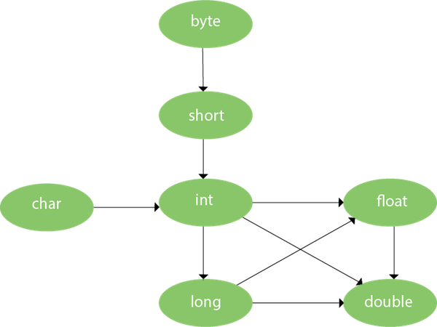

As displayed in the above diagram, byte can be promoted to short, int, long, float or double. The short datatype can be promoted to int, long, float or double. The char datatype can be promoted to int,long,float or double and so on.

### Example of Method Overloading with TypePromotion

1. class OverloadingCalculation1{
2. void sum(int a,long b){System.out.println(a+b);}
3. void sum(int a,int b,int c){System.out.println(a+b+c);}
5. public static void main(String args[]){
6. OverloadingCalculation1 obj=new OverloadingCalculation1();
7. obj.sum(20,20);//now second int literal will be promoted to long
8. obj.sum(20,20,20);
10. }
11. }

[Test it Now](https://www.javatpoint.com/opr/test.jsp?filename=OverloadingCalculation1)

Output:40

60

### Example of Method Overloading with Type Promotion if matching found

If there are matching type arguments in the method, type promotion is not performed.

1. class OverloadingCalculation2{
2. void sum(int a,int b){System.out.println("int arg method invoked");}
3. void sum(long a,long b){System.out.println("long arg method invoked");}
5. public static void main(String args[]){
6. OverloadingCalculation2 obj=new OverloadingCalculation2();
7. obj.sum(20,20);//now int arg sum() method gets invoked
8. }
9. }

[Test it Now](https://www.javatpoint.com/opr/test.jsp?filename=OverloadingCalculation2)

Output:int arg method invoked

### Example of Method Overloading with Type Promotion in case of ambiguity

If there are no matching type arguments in the method, and each method promotes similar number of arguments, there will be ambiguity.

1. class OverloadingCalculation3{
2. void sum(int a,long b){System.out.println("a method invoked");}
3. void sum(long a,int b){System.out.println("b method invoked");}
5. public static void main(String args[]){
6. OverloadingCalculation3 obj=new OverloadingCalculation3();
7. obj.sum(20,20);//now ambiguity
8. }
9. }

[Test it Now](https://www.javatpoint.com/opr/test.jsp?filename=OverloadingCalculation3)

Output:Compile Time Error

#### One type is not de-promoted implicitly for example double cannot be depromoted to any type implicitly.

# Method Overriding in Java

If subclass (child class) has the same method as declared in the parent class, it is known as **method overriding in Java**.

In other words, If a subclass provides the specific implementation of the method that has been declared by one of its parent class, it is known as method overriding.

### Usage of Java Method Overriding

* Method overriding is used to provide the specific implementation of a method which is already provided by its superclass.
* Method overriding is used for runtime polymorphism

#### Rules for Java Method Overriding

1. The method must have the same name as in the parent class
2. The method must have the same parameter as in the parent class.
3. There must be an IS-A relationship (inheritance).

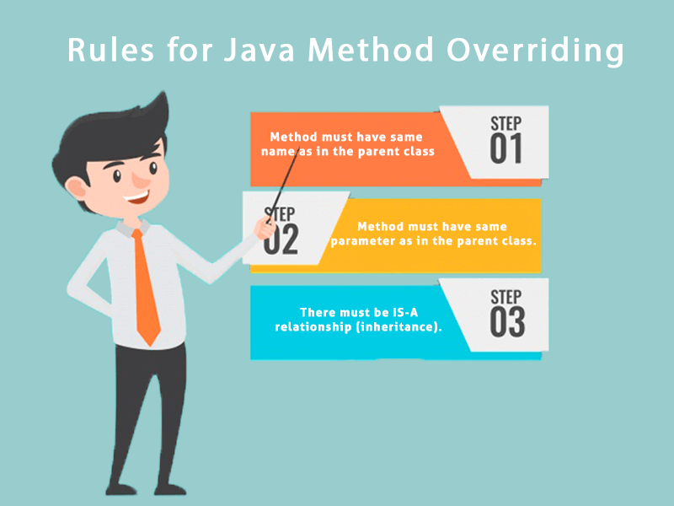

### Understanding the problem without method overriding

Let's understand the problem that we may face in the program if we don't use method overriding.

1. //Java Program to demonstrate why we need method overriding
2. //Here, we are calling the method of parent class with child
3. //class object.
4. //Creating a parent class
5. class Vehicle{
6. void run(){System.out.println("Vehicle is running");}
7. }
8. //Creating a child class
9. class Bike extends Vehicle{
10. public static void main(String args[]){
11. //creating an instance of child class
12. Bike obj = new Bike();
13. //calling the method with child class instance
14. obj.run();
15. }
16. }

[Test it Now](https://www.javatpoint.com/opr/test.jsp?filename=Bike)

Output:

Competitive questions on Structures in HindiKeep Watching

Vehicle is running

Problem is that I have to provide a specific implementation of run() method in subclass that is why we use method overriding.

### Example of method overriding

In this example, we have defined the run method in the subclass as defined in the parent class but it has some specific implementation. The name and parameter of the method are the same, and there is IS-A relationship between the classes, so there is method overriding.

1. //Java Program to illustrate the use of Java Method Overriding
2. //Creating a parent class.
3. class Vehicle{
4. //defining a method
5. void run(){System.out.println("Vehicle is running");}
6. }
7. //Creating a child class
8. class Bike2 extends Vehicle{
9. //defining the same method as in the parent class
10. void run(){System.out.println("Bike is running safely");}
12. public static void main(String args[]){
13. Bike2 obj = new Bike2();//creating object
14. obj.run();//calling method
15. }
16. }

[Test it Now](https://www.javatpoint.com/opr/test.jsp?filename=Bike2)

Output:

Bike is running safely

### A real example of Java Method Overriding

Consider a scenario where Bank is a class that provides functionality to get the rate of interest. However, the rate of interest varies according to banks. For example, SBI, ICICI and AXIS banks could provide 8%, 7%, and 9% rate of interest.

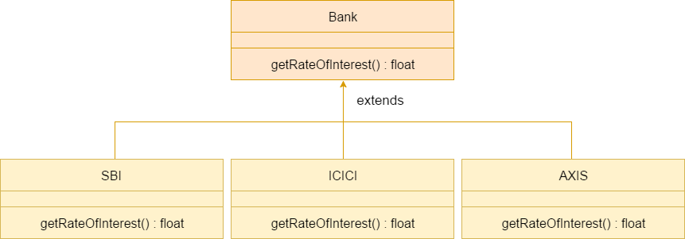

#### Java method overriding is mostly used in Runtime Polymorphism which we will learn in next pages.

1. //Java Program to demonstrate the real scenario of Java Method Overriding
2. //where three classes are overriding the method of a parent class.
3. //Creating a parent class.
4. class Bank{
5. int getRateOfInterest(){return 0;}
6. }
7. //Creating child classes.
8. class SBI extends Bank{
9. int getRateOfInterest(){return 8;}
10. }
12. class ICICI extends Bank{
13. int getRateOfInterest(){return 7;}
14. }
15. class AXIS extends Bank{
16. int getRateOfInterest(){return 9;}
17. }
18. //Test class to create objects and call the methods
19. class Test2{
20. public static void main(String args[]){
21. SBI s=new SBI();
22. ICICI i=new ICICI();
23. AXIS a=new AXIS();
24. System.out.println("SBI Rate of Interest: "+s.getRateOfInterest());
25. System.out.println("ICICI Rate of Interest: "+i.getRateOfInterest());
26. System.out.println("AXIS Rate of Interest: "+a.getRateOfInterest());
27. }
28. }

[Test it Now](https://www.javatpoint.com/opr/test.jsp?filename=Test2)

Output:

SBI Rate of Interest: 8

ICICI Rate of Interest: 7

AXIS Rate of Interest: 9

### Can we override static method?

No, a static method cannot be overridden. It can be proved by runtime polymorphism, so we will learn it later.

### Why can we not override static method?

It is because the static method is bound with class whereas instance method is bound with an object. Static belongs to the class area, and an instance belongs to the heap area.

### Can we override java main method?

No, because the main is a static method.

# Difference between method overloading and method overriding in java

There are many differences between method overloading and method overriding in java. A list of differences between method overloading and method overriding are given below:

|  |  |  |
| --- | --- | --- |
| **No.** | **Method Overloading** | **Method Overriding** |
| 1) | Method overloading is used *to increase the readability* of the program. | Method overriding is used *to provide the specific implementation* of the method that is already provided by its super class. |
| 2) | Method overloading is performed *within class*. | Method overriding occurs *in two classes* that have IS-A (inheritance) relationship. |
| 3) | In case of method overloading, *parameter must be different*. | In case of method overriding, *parameter must be same*. |
| 4) | Method overloading is the example of *compile time polymorphism*. | Method overriding is the example of *run time polymorphism*. |
| 5) | In java, method overloading can't be performed by changing return type of the method only. *Return type can be same or different* in method overloading. But you must have to change the parameter. | *Return type must be same or covariant* in method overriding. |